**Scrap collector - Use case detail**

1. **<Guest> Overview Use Case**

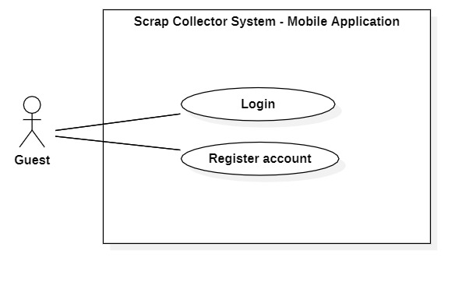

Figure 1 - Guest Overview Use Case

* 1. **Login**

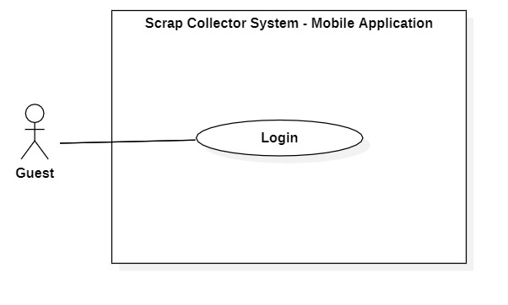

Figure 2 - <Guest> Login

|  |  |  |  |
| --- | --- | --- | --- |
| **USE CASE – SCHS_UC_1** | | | |
| **Use Case No.** | SCHS _UC_1 | **Use Case Version** | 1.0 |
| **Use Case Name** | Login | | |
| **Author** | Nguyen Duy Dat | | |
| **Date** | 26/1/2020 | **Priority** | Normal |
| **Actor:**   * Guest   **Summary:**   * Allow guest to log in the system.   **Goal:**   * Guest can log in the system with specific role.   **Triggers:**   * Guest sends login command.   **Preconditions:** N/A  **Post conditions:**   * Success: Guest is exactly authorized with specific role in the system. * Fail: System shows error messages.   **Main Success Scenario:**   |  |  |  | | --- | --- | --- | | **Step** | **Actor Action** | **System Response** | | 1 | Guest goes to login view. | System requires identity information from Guest:  - “Tên đăng nhập” (required): text input.  - “Mật khẩu” (required): text input.  - “Đăng nhập” button.  - “Đăng kí tài khoản” button | | 2 | Guest inputs required information. |  | | 3 | Guest presses “Đăng nhập” button. | System validate information. [Exception 1] [Exception 2][Exception 3] ][Exception 4] | | 4 |  | System let Guest to the “Trang chủ” screen based on specific role. |   **Alternative Scenario: N/A**  **Exceptions:**   |  |  |  | | --- | --- | --- | | **No** | **Actor Action** | **System Response** | | 1 |  | System shows message the "Không có kết nối Internet" when the internet is lost. | | 2 | Guest let “Tên đăng nhập” input empty | Focus on “Tên đăng nhập” filed, show error message “Không để trống thông tin này” | | 3 | Guest let “Mật khẩu” input empty | Focus on “Mật khẩu” filed, show error message “Không để trống thông tin này” | | 4 | Guest enter wrong identity information. | System shows error message “Tên đăng nhâp hoặc mật khẩu không chính xác. Vui lòng thử lại”. |   **Relationships:** N/A  **Business Rules:**   * Password is encrypted before being sent to server. * After login to system, guest will be redirected to specific view based on their role on the system: homeowner, collector or admin. * If role is “Collector”, the system will display to Collector view. * If role is “Homeowner”, the system will display to Homeowner view. * If role is “Admin”, the system will display to Admin Dashboard view. | | | |

Table 1 <Guest> Login use case specification

* 1. **Register**

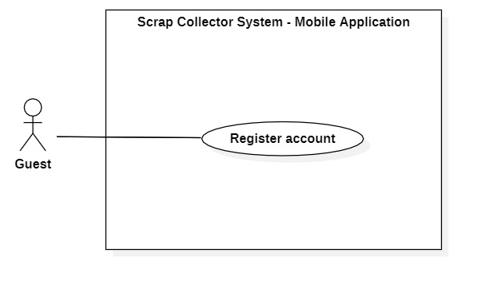

Figure 3 - <Guest> Register account

|  |  |  |  |
| --- | --- | --- | --- |
| **USE CASE – SCHS_UC_2** | | | |
| **Use Case No.** | SCHS _UC_2 | **Use Case Version** | 1.0 |
| **Use Case Name** | Register account | | |
| **Author** | Nguyen Duy Dat | | |
| **Date** | 26/1/2020 | **Priority** | Normal |
| **Actor:**   * Guest   **Summary:**   * Allow guest to create an account the system.   **Goal:**   * Guest can have an account in the system with specific role: Homeowner or Collector.   **Triggers:**   * Guest presses “Đăng kí tài khoản” button on Login screen.   **Preconditions:** N/A  **Post conditions:**   * Success: A new account is created with specific role in the system. * Fail: System shows error messages. Account is not created.   **Main Success Scenario:**   |  |  |  | | --- | --- | --- | | **Step** | **Actor Action** | **System Response** | | 1 | Guest goes to register view. | System requires identity information from Guest:  - “Tên đăng nhập” (required): text input  - “Email”: text input must contain “@”.  - “Mật khẩu” (required): text input with at least 6 characters.  - “Xác nhận mật khẩu” (required): text input, must be same as Password.  - “Số điện thoại” (required): text input with right phone number format.  - “Địa chỉ” (required): text input or GPS location.  - “Họ”: text input.  - “Tên” (required): text input.  - Role (required): ratio choice containing 2 options:   * “Tôi muốn bán ve chai” * “Tôi là người mua ve chai” | | 2 | Guest inputs full required information |  | | 3 | Guest presses “Đăng kí” button. | System validates inputs[Exception 1] [Exception 2] [Exception 3] [Exception 4] [Exception 5] [Exception 6] [Exception 7] [Exception 8] [Exception 9] [Exception 10] [Exception 11] [Exception 12] [Exception 13] | | 4 |  | System creates account with specific role and let Guest to “Trang chủ” screen based on specific role. |   **Alternative Scenario:**  **Exceptions:**   |  |  |  | | --- | --- | --- | | **No** | **Actor Action** | **System Response** | | 1 |  | System shows message the "Không có kết nối Internet" when the internet is lost. | | 2 | Guest let “Tên đăng nhập” input empty | Focus in “Tên đăng nhập” field. Show error message “Không để trống thông tin này” | | 3 |  | System focuses on “Tên đăng nhập” field and show error message “Đã có người sử dụng tên đăng nhập này, vui lòng chọn tên đăng nhập khác” when the username is duplicated. | | 4 | Guest let “Mật khẩu” input empty | Focus in “Mật khẩu” field. Show error message “Không để trống thông tin này” | | 5 | Guest let “Số điện thoại” input empty | Focus in “Số điện thoại” field. Show error message “Không để trống thông tin này” | | 6 | Guest let “Địa chỉ” input empty | Focus in “Địa chỉ” field. Show error message “Không để trống thông tin này” | | 7 | Guest choose “Địa chỉ” not in Viet Nam | Focus in ““Địa chỉ” field. Show error message “Địa chỉ không hợp lệ” | | 8 | Guest let “Tên” input empty | Focus in “Tên” field. Show error message “Không để trống thông tin này” | | 9 | Guest does not choose Role | Focus in Role field. Show error message “Vui lòng chọn vai trò” | | 10 | Guest let “Mật khẩu” less than 6 letters | Focus in “Mật khẩu” field. Show error message “Mật khẩu tối thiểu 6 kí tự”. | | 11 | “Xác nhận mật khẩu” is not same as “Mật khẩu”, empty or less than 6 letters. | Focus in “Xác nhận mật khẩu” field. Show error message “Xác nhận mật khẩu không khớp”. | | 12 | Guest input wrong Email format | Focus in Email field. Show error message “Địa chỉ Email không hợp lệ” | | 13 | Guest input wrong Phone number format | Focus in “Số điện thoại” field. Show error message “Số điện thoại không hợp lệ” |   **Relationships:** N/A  **Business Rules:**   * Password is encrypted before being sent to server. * Email must contain “@”. * Phone number must be in right format. * After register, the user will be logged in to the system and be redirected to “Trang chủ” screen. * If user register with “Tôi muốn bán ve chai” choice, new account will be created with role: Homeowner. * If user register with “Tôi là người mua ve chai” choice, new account will be created with role: Collector. | | | |

Table 2 <Guest> Register use case specification

1. **<Homeowner> Overview Use Case**

**2.1 Post scrap**

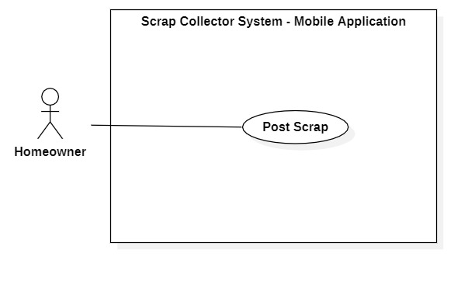

Figure 4 - <Homeowner> Post scrap

|  |  |  |  |
| --- | --- | --- | --- |
| **USE CASE – SCHS_UC_3** | | | |
| **Use Case No.** | SCHS _UC_3 | **Use Case Version** | 1.0 |
| **Use Case Name** | Post scrap | | |
| **Author** | Nguyen Duy Dat | | |
| **Date** | 26/1/2020 | **Priority** | Normal |
| **Actor:**   * Homeowner   **Summary:**   * Allow Homeowner to post scrap for sale.   **Goal:**   * Homeowner post one or many scraps for sale in a post.   **Triggers:**   * Homeowner presses “Đăng bán” button.   **Preconditions:**   * User must sign in as a Homeowner   **Post conditions:**   * Success: A new post is created. * Fail: System shows error messages. Post is not created.   **Main Success Scenario:**   |  |  |  | | --- | --- | --- | | **Step** | **Actor Action** | **System Response** | | 1 | Homeowner goes to post scrap view. | System requires identity information from Homeowner:  - “Tiêu đề” (required): text input  - “Ảnh” (required): at least 1 image and at most 5 images  - Giá bán: number  - “Mô tả”: text input  - “Phân loại” (required): selection  - “Thời gian rãnh”: selection  - “Địa chỉ”: text input or GPS location  - “Số điện thoại liên lạc”: number | | 2 | Homeowner inputs full required information |  | | 3 | Homeowner presses “Đăng bán” button. | System validates all required fields [Exception 1] [Exception 2] [Exception 3] [Exception 4] [Exception 5] | | 4 |  | System creates new post and let Homeowner to “Trang chủ” screen |   **Alternative Scenario: N/A**  **Exceptions:**   |  |  |  | | --- | --- | --- | | **No** | **Actor Action** | **System Response** | | 1 |  | System shows message the "Không có kết nối Internet" when the internet is lost. | | 2 | Homeowner let “Tiêu đề” input empty | Focus in “Tiêu đề” field. Show error message “Không để trống thông tin này”. | | 3 | Homeowner let “Hình ảnh” empty | Focus in “Hình ảnh” field. Show error message “Không để trống thông tin này”. | | 4 | Homeowner does not select “Phân loại” | Focus in “Phân loại” field. Show error message “Chọn loại ve chai”. | | 5 | Homeowner chooses “Địa chỉ” not in Viet Nam | Focus in “Địa chỉ” field. Show error message “Địa chỉ không hợp lệ” |   **Relationships:** N/A  **Business Rules:**   * Each scrap post can have one or many scraps. * Created post will have “New” status. * If Homeowner doesn’t input Price field, show price as “Giá thương lượng”. * If Homeowner doesn’t select available time, show available time as “Liên hệ” * If Homeowner doesn’t input address, get address from Homeowner profile. * If Homeowner doesn’t input contact number, get phone number from Homeowner profile. * System records time of the post automatically. | | | |

Table 3 <Homeowner> Post scrap use case specification

1. **<Collector> Overview Use Case**

**3.1 Search near-by scrap**

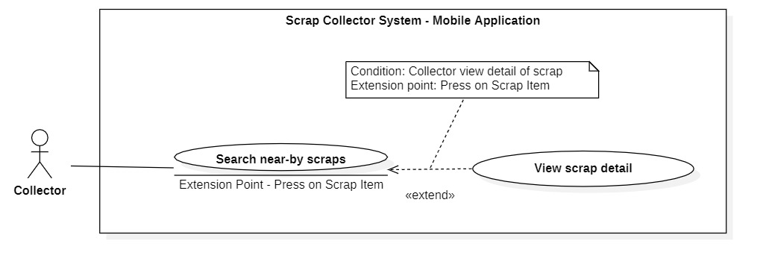

Figure 5 - < Collector > Search near-by scrap

|  |  |  |  |
| --- | --- | --- | --- |
| **USE CASE – SCHS_UC_4** | | | |
| **Use Case No.** | SCHS _UC_4 | **Use Case Version** | 1.0 |
| **Use Case Name** | Search near-by scrap | | |
| **Author** | Nguyen Duy Dat | | |
| **Date** | 26/1/2020 | **Priority** | Normal |
| **Actor:**   * Collector   **Summary:**   * Allow collector to find near-by scrap by radius, scrap category.   **Goal:**   * Collector can see near-by scrap post to book.   **Triggers:**   * Collector press “Trang chủ” icon in tab navigator.   **Preconditions:**   * User must login in the system with role “Collector” * Collector have registered his/her location.   **Post conditions:**   * Success: A list of scrap post is shown on screen. * Fail: System shows error messages.   **Main Success Scenario:**   |  |  |  | | --- | --- | --- | | **Step** | **Actor Action** | **System Response** | | 1 | Collector go to “Trang chủ” screen | System shows list of scrap posts in radius of 5km based on collector’s location, with any kind of category. [Alternative 1] [Alternative 2] [Exception 1] [Exception 2] |   **Alternative Scenario:**   |  |  |  | | --- | --- | --- | | **No** | **Actor Action** | **System Response** | | 1 | Collector select length of radius in “Phạm vi” selection | System searches scrap post with selected radius and shows search result | | 2 | Collector select type of scrap category in “Phân loại” selection | System searches scrap post with selected category and shows search result |   **Exceptions:**   |  |  |  | | --- | --- | --- | | **No** | **Actor Action** | **System Response** | | 1 |  | System shows message the "Không có kết nối Internet" when the internet is lost. | | 2 |  | System shows message the "Không thể tải được bản đồ" when the map API is lost. |   **Relationships:** [View scrap detail]  **Business Rules:**   * Only return scrap posts that have “New” status | | | |

Table 4 <Collector > Search near-by scrap use case specification

**3.2 View Scrap detail**



Figure 6 - < Collector > View scrap detail

|  |  |  |  |
| --- | --- | --- | --- |
| **USE CASE – SCHS_UC_** | | | |
| **Use Case No.** | SCHS _UC_ | **Use Case Version** | 1.0 |
| **Use Case Name** | View scrap detail | | |
| **Author** | Nguyen Duy Dat | | |
| **Date** | 26/1/2020 | **Priority** | Normal |
| **Actor:**   * Collector   **Summary:**   * Allow Collector to view scrap detail.   **Goal:**   * Collector views detail of the scrap then decide whether to buy or not.   **Triggers:**   * Collector presses the item of scrap.   **Preconditions:**   * User must login in the system with role “Collector”. * Collector searchs near-by scrap.   **Post conditions:**   * Success: A new post is created. * Fail: System shows error messages. Post is not created.   **Main Success Scenario:**   |  |  |  | | --- | --- | --- | | **Step** | **Actor Action** | **System Response** | | 1 | Collector press in the Item of scrap on search result list | System shows the detail of scrap with:   * “Tiêu đề” * “Giá bán” * “Hình ảnh” * “Phân loại” * “Mô tả” * “Thời gian rãnh” * “Trả giá” button * “Gọi” button * “Chat” button * “Đặt lịch” button   [Exception 1] [Exception 2] |   **Alternative Scenario:**  **Exceptions:**   |  |  |  | | --- | --- | --- | | **No** | **Actor Action** | **System Response** | | 1 |  | System shows error message the "Không có kết nối Internet" when the internet is lost. | | 2 |  | System shows error message the "Không thể tìm thấy bài đăng" when cannot find the post. |   **Relationships:** [Search near-by scrap]  **Business Rules:** | | | |

Table <Collector> View scrap detail use case specification

1. **<Admin> Overview Use Case**
2. **<Authorized User> Overview Use Case**

**5.1 <Authorized User> Logout**

Figure -<Authorized User> Logout

|  |  |  |  |
| --- | --- | --- | --- |
| **USE CASE – SCHS_UC_** | | | |
| **Use Case No.** | SCHS _UC_ | **Use Case Version** | 1.0 |
| **Use Case Name** | Logout | | |
| **Author** | Nguyen Duy Dat | | |
| **Date** | 26/1/2020 | **Priority** | Normal |
| **Actor:**   * Authorized User   **Summary:**   * This use case allows the Authorized User to log out of the system.   **Goal:**   * The Authorized User logs out of the system successfully.   **Triggers:**   * User presses “Đăng xuất” button.   **Preconditions:**   * User has already logged in the system with the role that has been authorized.   **Post conditions:**   * Success: The Authorized User logs out of the system successfully, system moves to Login Screen. * Fail: System shows error messages.   **Main Success Scenario:**   |  |  |  | | --- | --- | --- | | **Step** | **Actor Action** | **System Response** | | 1 | The Authorized User presses on “Đăng xuất” button. | System clear the session of that Authorized User then shows Login screen. [Exception 1] |   **Alternative Scenario:** N/A  **Exceptions:**   |  |  |  | | --- | --- | --- | | **No** | **Actor Action** | **System Response** | | 1 |  | System shows error message the "Không có kết nối Internet" when the internet is lost. |   **Relationships:** N/A  **Business Rules:**   * Only Authorized User can log out. * After the Authorized User logs out, clear all sessions of that user. | | | |

Table < Authorized User> Logout use case specification

**5.2 <Authorized User> View Profile**

Figure -<Authorized User> View profile

|  |  |  |  |
| --- | --- | --- | --- |
| **USE CASE – SCHS_UC_** | | | |
| **Use Case No.** | SCHS _UC_ | **Use Case Version** | 1.0 |
| **Use Case Name** | View Profile | | |
| **Author** | Nguyen Duy Dat | | |
| **Date** | 26/1/2020 | **Priority** | Normal |
| **Actor:**   * Authorized User   **Summary:**   * Allow Authorized User to view his/her profile.   **Goal:**   * Authorized User views profile.   **Triggers:**   * User chooses “Tài khoản” tab in tab navigation.   **Preconditions:**   * User has already logged in the system with the role that has been authorized.   **Post conditions:**   * Success: System shows Profile screen. * Fail: System shows error messages.   **Main Success Scenario:**   |  |  |  | | --- | --- | --- | | **Step** | **Actor Action** | **System Response** | | 1 | Authorized User chooses “Tài khoản” tab in tab navigation. | System shows Profile Screen with:   * “Ảnh đại diện” * “Tên” * “Tên đăng nhập” * “Số điện thoại” * “Địa chỉ” * “Chỉnh sửa hồ sơ” button * “Đăng xuất” button * “Xóa tài khoản” button   [Exception 1] |   **Alternative Scenario:** N/A  **Exceptions:**   |  |  |  | | --- | --- | --- | | **No** | **Actor Action** | **System Response** | | 1 |  | System shows error message the "Không có kết nối Internet" when the internet is lost. |   **Relationships:** [Update profile] [Deactivate account]  **Business Rules:**   * Only Authorized User can view profile * Password mustn’t be shown | | | |

**5.3 <Authorized User> Update Profile**

Figure -<Authorized User> Update profile

|  |  |  |  |
| --- | --- | --- | --- |
| **USE CASE – SCHS_UC_** | | | |
| **Use Case No.** | SCHS _UC_ | **Use Case Version** | 1.0 |
| **Use Case Name** | Update Profile | | |
| **Author** | Nguyen Duy Dat | | |
| **Date** | 26/1/2020 | **Priority** | Normal |
| **Actor:**   * Authorized User   **Summary:**   * Allow Authorized User to update his/her profile.   **Goal:**   * Authorized User updates profile.   **Triggers:**   * User presses “Chỉnh sửa hồ sơ” button in “Tài khoản” screen.   **Preconditions:**   * User has already logged in the system with the role that has been authorized.   **Post conditions:**   * Success: System shows Update Profile screen. * Fail: System shows error messages.   **Main Success Scenario:**   |  |  |  | | --- | --- | --- | | **Step** | **Actor Action** | **System Response** | | 1 | Authorized User presses “Chỉnh sửa hồ sơ” button in “Tài khoản” screen. | System shows Update Profile Screen with:   * “Chỉnh sửa hồ sơ” title * “Ảnh đại diện”: image, editable * “Họ”: text, editable * “Tên”: text, editable * “Số điện thoại”: text, editable * “Địa chỉ”: text, editable * “Mật khẩu”: hidden text, editable * Confirm password: text, editable * “Lưu chỉnh sửa” button * “Hủy” button | | 2 | Authorized User edit editable fields |  | | 3 | Authorized User presses “Lưu chỉnh sửa” button. [Alternative 1] | System saves new information and shows Profile screen with new information. [Exception 1][Exception 2] [Exception 3][Exception 4] [Exception 5] [Exception 6] [Exception 7] [Exception 8] |   **Alternative Scenario:**   |  |  |  | | --- | --- | --- | | **No** | **Actor Action** | **System Response** | | 1 | Authorized User presses “Hủy” button. | System shows “Tài khoản” screen. |   **Exceptions:**   |  |  |  | | --- | --- | --- | | **No** | **Actor Action** | **System Response** | | 1 |  | System shows error message the "Không có kết nối Internet" when the internet is lost. | | 2 | Guest let Full name input empty | Focus in Full name field. Show error message “Không để trống thông tin này” | | 3 | Guest let Phone number input empty | Focus in Phone number field. Show error message “Không để trống thông tin này” | | 4 | Guest let Address input empty | Focus in Address field. Show error message “Không để trống thông tin này” | | 5 | Guest choose Address not in Viet Nam | Focus in Address field. Show error message “Địa chỉ không hợp lệ” | | 6 | Guest let Password less than 6 letters | Focus in Password field. Show error message “Mật khẩu tối thiểu 6 kí tự”. | | 7 | Confirmed password is not same as Password, empty or less than 6 letters. | Focus in Confirm Password field. Show error message “Xác nhận mật khẩu không khớp”. | | 8 | Guest input wrong Phone number format | Focus in Email field. Show error message “Số điện thoại không hợp lệ” |   **Relationships:** [View profile]  **Business Rules:**   * Only Authorized User can update profile * Password mustn’t be shown * Phone number must be in the phone number format | | | |

**5.4 <Authorized User> De-activate account**

Figure -<Authorized User> De-activate account

|  |  |  |  |
| --- | --- | --- | --- |
| **USE CASE – SCHS_UC_** | | | |
| **Use Case No.** | SCHS _UC_ | **Use Case Version** | 1.0 |
| **Use Case Name** | Deactivate account | | |
| **Author** | Nguyen Duy Dat | | |
| **Date** | 26/1/2020 | **Priority** | Normal |
| **Actor:**   * Authorized User   **Summary:**   * Allow Authorized User to deactivate his/her account.   **Goal:**   * Authorized User deactivate account.   **Triggers:**   * User presses “Xóa tài khoản” button in tab navigation.   **Preconditions:**   * User has already logged in the system with the role that has been authorized.   **Post conditions:**   * Success: System shows Success message. * Fail: System shows error messages.   **Main Success Scenario:**   |  |  |  | | --- | --- | --- | | **Step** | **Actor Action** | **System Response** | | 1 | Authorized User presses “Xóa tài khoản” button in Profile screen. | System shows Confirmation pop up with:   * “Bạn cần nhập password để xác nhận xóa tài khoản” Message * “Mật khẩu”: text input * “Xác nhận” button * “Hủy” button | | 2 | User inputs Password and presses “Xác nhận” button. [Alternative 1] | System checks password and deactivate account. [Exception 1] [Exception 2] |   **Alternative Scenario:**   |  |  |  | | --- | --- | --- | | **No** | **Actor Action** | **System Response** | | 1 | User presses “Hủy” button. | System shows back “Tài khoản” screen. |   **Exceptions:**   |  |  |  | | --- | --- | --- | | **No** | **Actor Action** | **System Response** | | 1 |  | System shows error message the "Không có kết nối Internet" when the internet is lost. | | 2 | User inputs wrong password. | System shows error message the "Mật khẩu không chính xác" |   **Relationships:** [View profile]  **Business Rules:**   * Only Authorized User can deactivate account * Password must be encrypted before being sent to the server. * The account of that user should be saved in database and is masked as “is deleted”. | | | |

|  |  |  |  |
| --- | --- | --- | --- |
| **USE CASE – SCHS_UC_** | | | |
| **Use Case No.** | SCHS _UC_ | **Use Case Version** | 1.0 |
| **Use Case Name** | Post scrap | | |
| **Author** | Nguyen Duy Dat | | |
| **Date** | 26/1/2020 | **Priority** | Normal |
| **Actor:**   * Homeowner   **Summary:**   * Allow homeowner to post scrap for sale.   **Goal:**   * Homeowner post one or many scraps for sale in a post.   **Triggers:**   * User presses “Đăng bán” button.   **Preconditions:**   * User must be a homeowner   **Post conditions:**   * Success: A new post is created. * Fail: System shows error messages. Post is not created.   **Main Success Scenario:**   |  |  |  | | --- | --- | --- | | **Step** | **Actor Action** | **System Response** | | 1 |  |  | | 2 |  |  | | 3 |  |  |   **Alternative Scenario:**   |  |  |  | | --- | --- | --- | | **No** | **Actor Action** | **System Response** | | 1 |  |  |   **Exceptions:**   |  |  |  | | --- | --- | --- | | **No** | **Actor Action** | **System Response** | | 1 |  |  | | 2 |  |  |   **Relationships:** N/A  **Business Rules:**   * Each scrap post can have one or many scrap. | | | |

Table < > use case specification